VE Day – 8 May 1945

THE PARTY!

Mr. J. Keohane – Roath Park Primary School

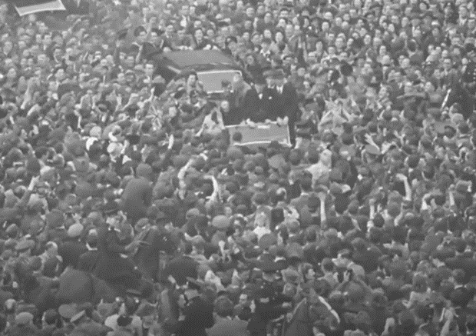

Watch this video showing celebrations on VE day (click on it)
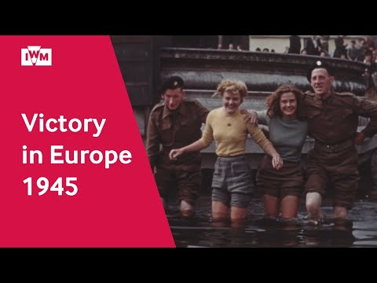

- Answer these questions: https://forms.office.com/Pages/ResponsePage.aspx?id=Ug4_TzS3ZEGUCRtgHRR5kwR7w2UXxDBIhc67OPJvzoZUQ1JJOUFVWUtEMlRPVEpJOUdHOVJENE1COC4u

- Write a newspaper article for the VE Day celebrations

